**Assignment 01 – SQL Basics**

**1. Select employee details of dept number 10 or 30**

SELECT *

FROM emp

WHERE DeptNo IN (10, 30);

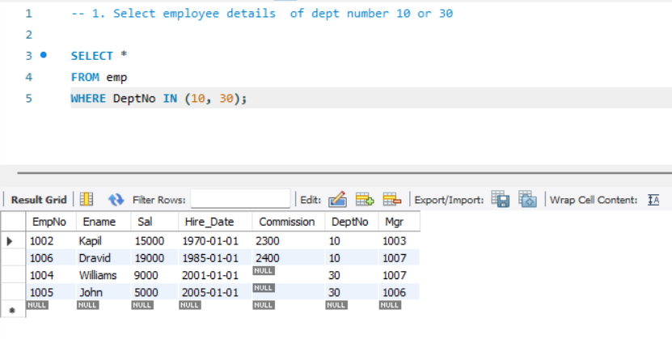

**2. Write a query to fetch all the dept details with more than 1 Employee**

SELECT *

FROM dept

WHERE DeptNo IN (

SELECT DeptNo FROM emp

GROUP BY DeptNo

HAVING COUNT(*) > 1

);

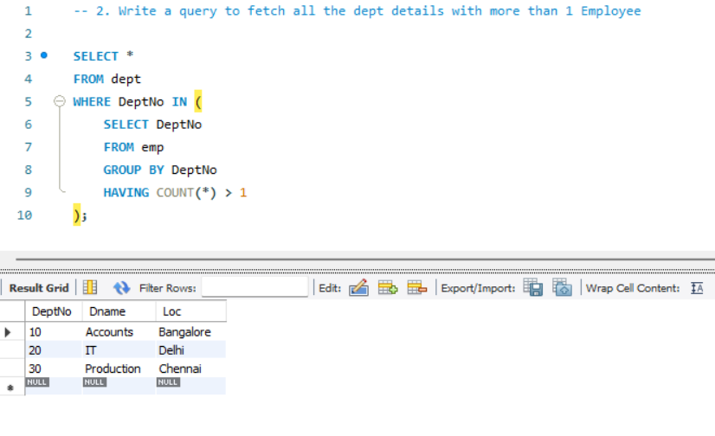

**3. Write a query to fetch employee details whose name starts with the letter “S”**

SELECT *

FROM emp

WHERE Ename LIKE 'S%';

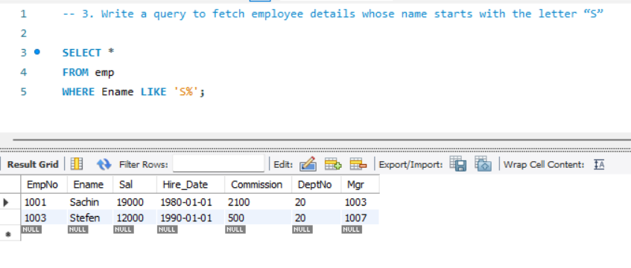

**4. Select Emp Details Whose experience is more than 2 years**

SELECT * FROM emp

WHERE DATEDIFF(CURRENT_DATE(), Hire_Date) >= 730;

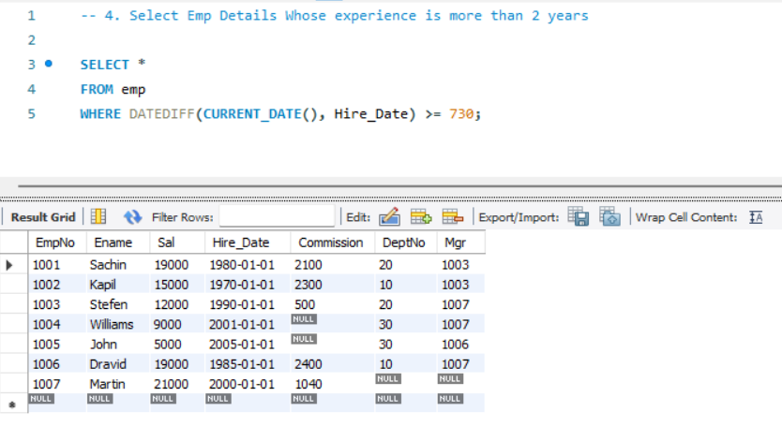

**5. Write a SELECT statement to replace the char “a” with “#” in Employee Name**

SELECT REPLACE(Ename, 'a', '#') AS Modified_Ename

FROM emp;

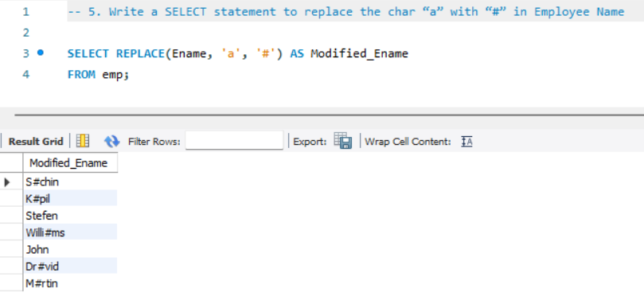

**6. Write a query to fetch employee name and his/her manager’s name**

SELECT e.Ename AS Employee_Name, m.Ename AS Manager_Name

FROM emp e

LEFT JOIN emp m

ON e.Mgr = m.EmpNo;

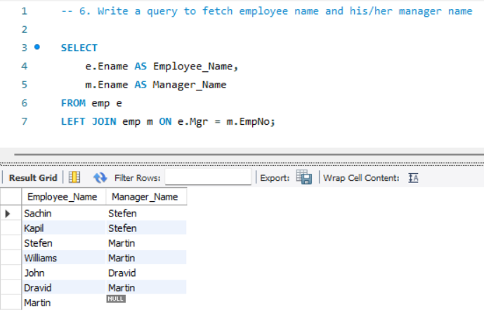

**7. Fetch Dept Name, Total Salary of the Dept**

SELECT d.Dname, SUM(e.Sal) AS Total_Salary

FROM dept d

LEFT JOIN emp e

ON d.DeptNo = e.DeptNo

GROUP BY d.DeptNo;

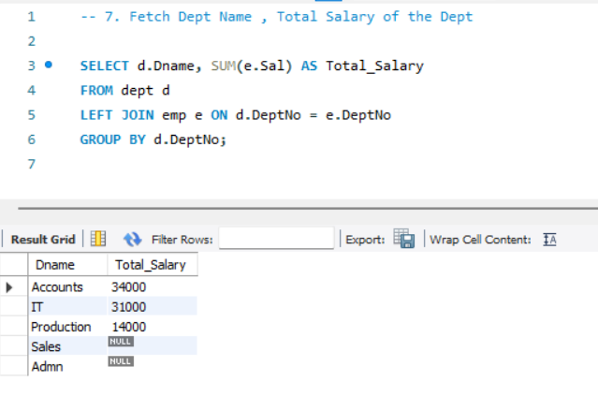

**8. Write a query to fetch ALL the employee details along with department name, department location, irrespective of employee existence in the department.**

SELECT e.*, d.Dname, d.Loc

FROM emp e

LEFT JOIN dept d

ON e.DeptNo = d.DeptNo;

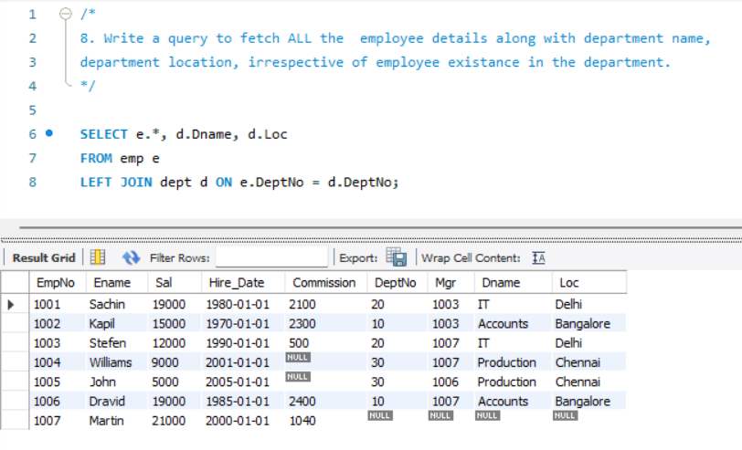

**9. Write an update statement to increase the employee salary by 10%**

UPDATE emp

SET Sal = Sal * 1.1

WHERE EmpNo IS NOT NULL;

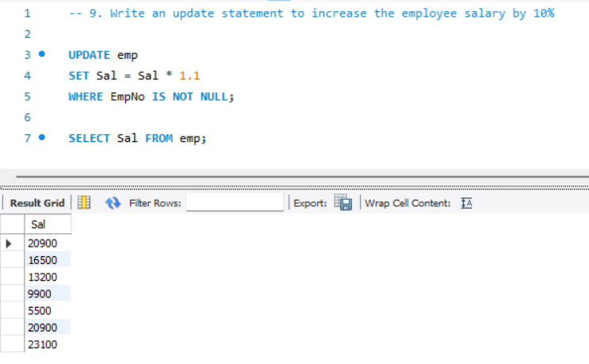

**10. Write a statement to delete employees belong to Chennai location.**

DELETE FROM emp

WHERE DeptNo IN (

SELECT DeptNo

FROM dept

WHERE Loc = 'Chennai'

);

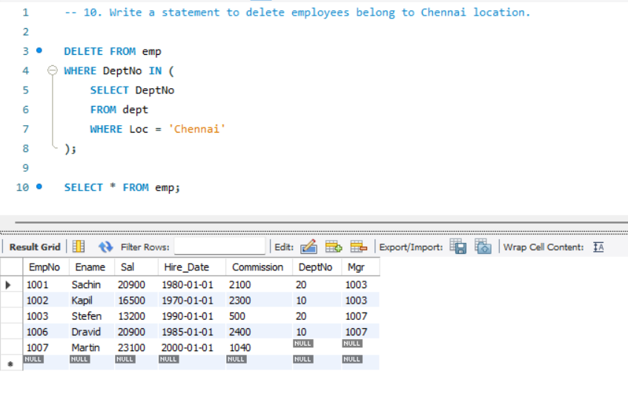

**11. Get Employee Name and gross salary (sal + comission)**

SELECT Ename, Sal + Commission AS Gross_Salary

FROM emp;

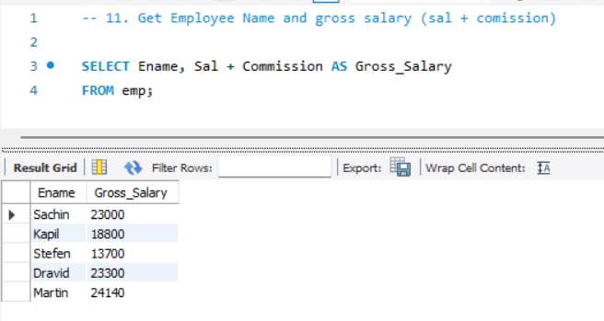

**12. Increase the data length of the column Ename of Emp table from 100 to 250 using ALTER statement**

ALTER TABLE emp

MODIFY COLUMN Ename VARCHAR(250);

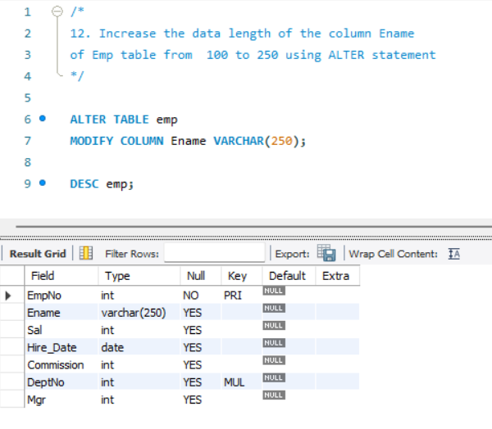

**13. Write query to get current datetime**

SELECT NOW() AS Current_Datetime;

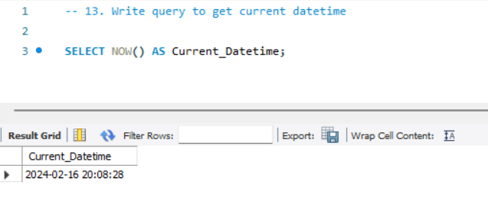

**14. Write a statement to create STUDENT table, with related 5 columns**

CREATE TABLE STUDENT (

SID INT PRIMARY KEY, Firstname VARCHAR(50),

Lastname VARCHAR(50), Gender VARCHAR(10), DOB DATE );

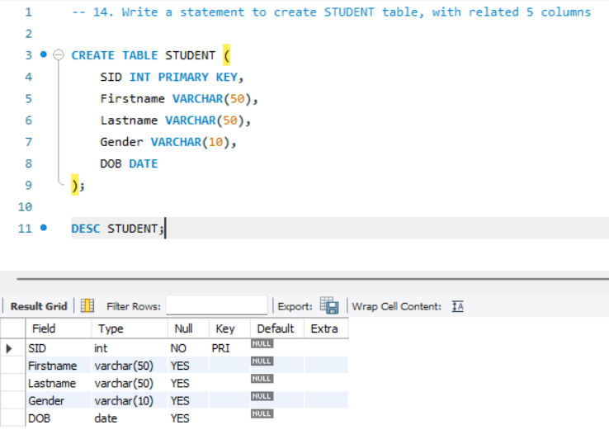

**15. Write a query to fetch number of employees in who is getting salary more than 10000**

SELECT COUNT(*)

FROM emp

WHERE Sal > 10000;

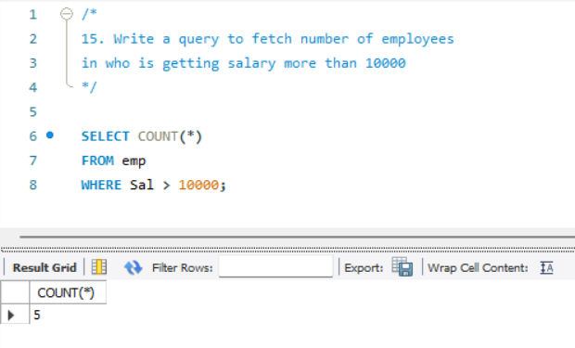

**16. Write a query to fetch minimum salary, maximum salary and average salary from emp table.**

SELECT

MIN(Sal) AS Minimum_Salary,

MAX(Sal) AS Maximum_Salary,

AVG(Sal) AS Average_Salary

FROM emp;

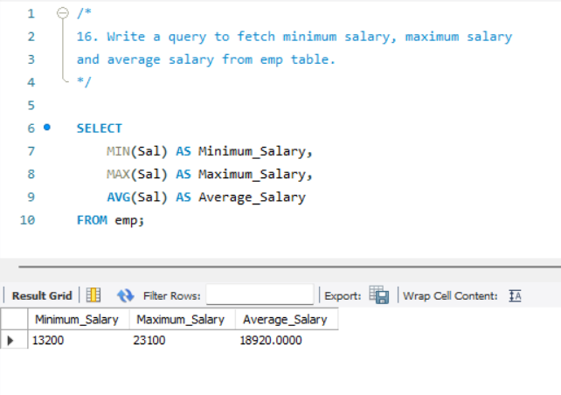

**17. Write a query to fetch number of employees in each location**

SELECT d.Loc, COUNT(*) AS Num_Emp

FROM dept d

JOIN emp e ON d.DeptNo = e.DeptNo

GROUP BY d.Loc;

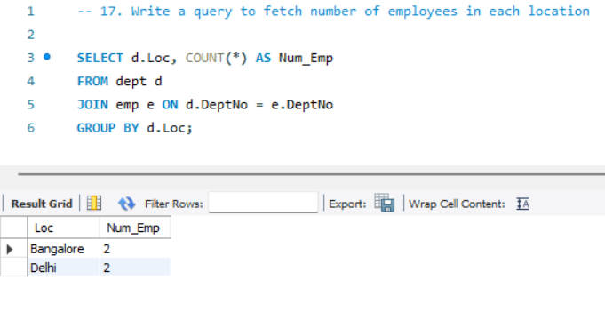

**18. Write a query to display employee names in descending order**

SELECT Ename

FROM emp

ORDER BY Ename DESC;

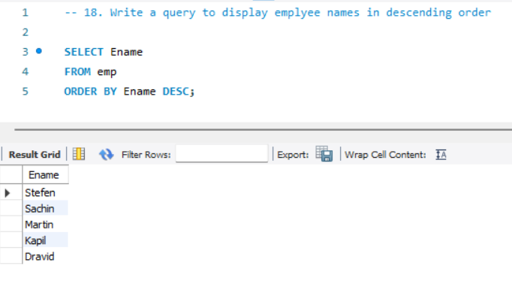

**19. Write a statement to create a new table(EMP_BKP) from the existing EMP table**

CREATE TABLE EMP_BKP AS

SELECT * FROM emp;

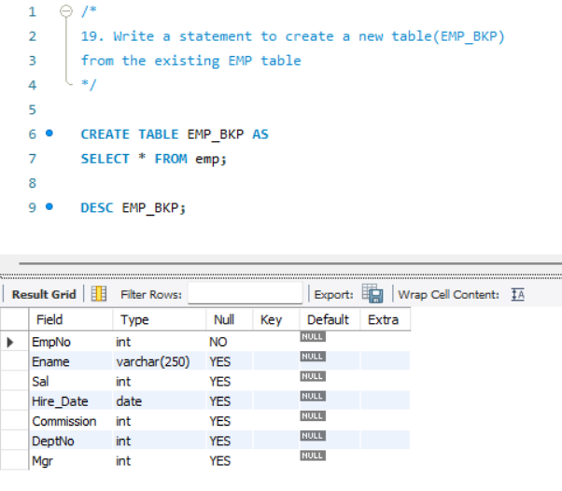

**20. Write a query to fetch first 3 characters from employee name appended with salary.**

SELECT CONCAT(SUBSTRING(Ename, 1, 3), '_', Sal) AS Result

FROM emp;

